To Volunteer or get newer info

https://www.texasrescuemap.com/muckmap

Mucking Tools and Procedures

**Mucking** - activities like removing wet carpets, flooring, drywall, mud, or other items to prepare a flooded home for drying out and renovations.

Mucking is hard and dirty work. There are a lot of tools and items needed to remove floorboards, drywall, and carpet safely. **Suggested clothing** is long sleeve shirt, pants (no shorts), and closed toed shoes. Remember, a lot of these homes may still be flooded or wet, so wear clothing that you wouldn’t mind throwing away!

## Safety tips:

* Shut off the power at the main circuit breaker before you start. Don’t skip this step it’s not worth it. Turn off gas at each individual appliance. Locate the main water cut off in case you damage a water pipe.
* Duct tape your refrigerator before moving it. Do not open. It will be a biological hazard quick. If possible, use metal screws to screw it closed and get it to the side of the road.
* Cut your carpet into small sheets, the water weight will prevent you from moving large pieces.
* Save the drywall for the end. Carpet covered in mud and drywall is even heavier than straight-up wet carpet.
* If the water level reached your roof, your ductwork is probably filled with water. Be careful taking it down.

## Suggested tools:

### Debris removalVentilatedLaundryBasketPearl_x.jpg

**Wheelbarrow (preferred) Buckets Laundry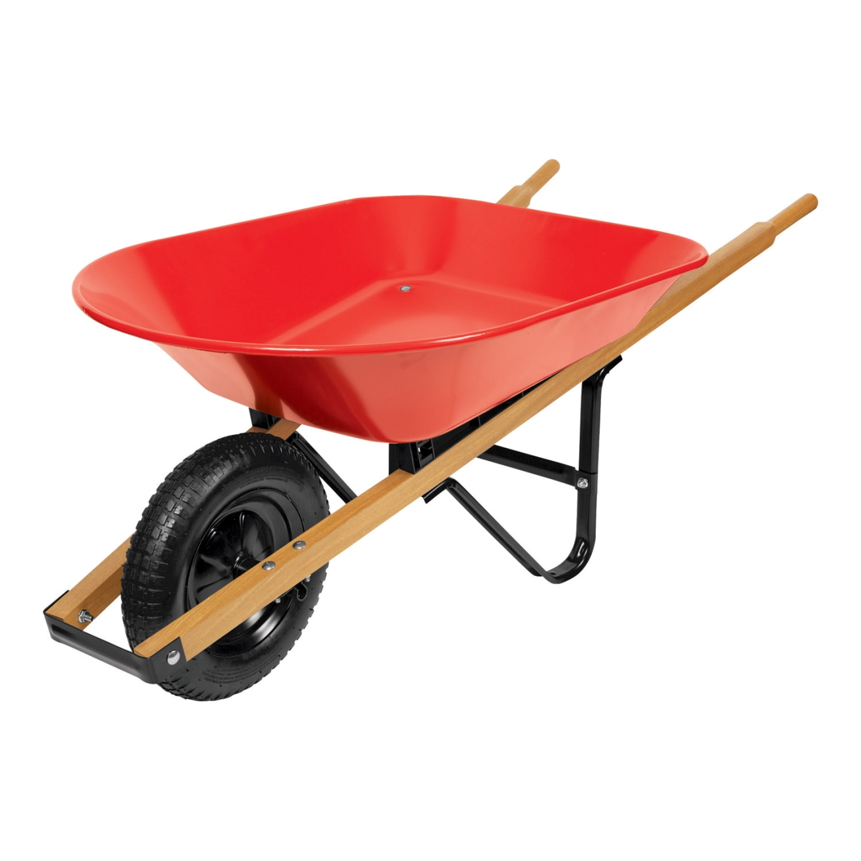 basket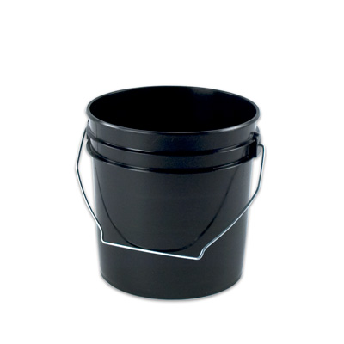**

### Safety wear (Highly Recommended)

Read OSHA’s guide on mold remediation: <https://www.osha.gov/Publications/OSHA3691.pdf>

**Safety Masks Glasses Gloves**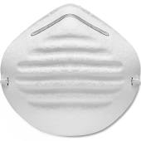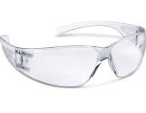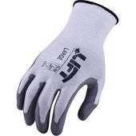

### Tools for Floorboard Removal:

**Circular saw Wrecking Bar Hammer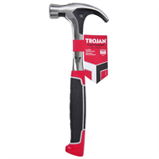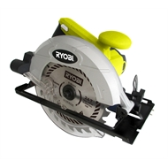 Chisel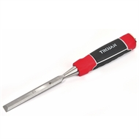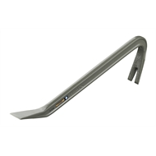**

Procedures for floorboard removal:

<https://www.bunnings.com.au/diy-advice/flooring/timber-floorboards/how-to-remove-floorboards>

Optional video: <https://www.youtube.com/watch?v=WlcAUU8JIdw>

### Tools for Carpet Removal:

**Box knife Pry bar Flat Screwdriver Wheelbarrow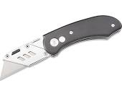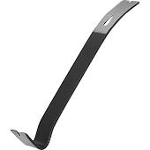**

image24.png

### Procedures for Carpet Removal:

<http://www.wikihow.com/Take-Out-Carpet>

Optional Video: <https://www.youtube.com/watch?v=5o80gbNnROU>

### Tools for Drywall Removal:

B**ox Knife Pry bar Hammer Drywall Saw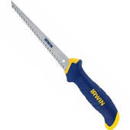**

****

### Procedures for Drywall Removal:

<http://www.wikihow.com/Remove-Drywall>

Optional Video: <https://www.youtube.com/watch?v=W2oLM5yZM5w&t=194s>

### How To Separate Your Debris So The City Will Pick It Up:

(english)

<http://www.houstontx.gov/solidwaste/CurbsideDebrisPDF.pdf>

(spanish)

<http://www.houstontx.gov/solidwaste/CurbsideDebrisPDF_SPN.pdf>